YUNPENG LING CS85 SUMMER2018

screenshot of XAMPP installing

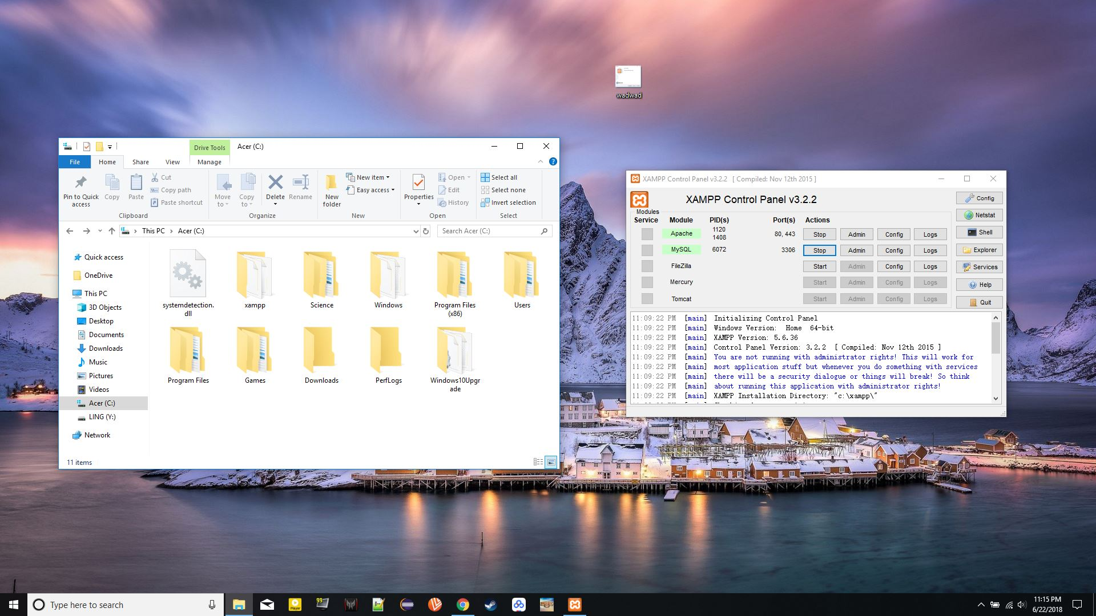  
screenshot of PHPStorm Installing

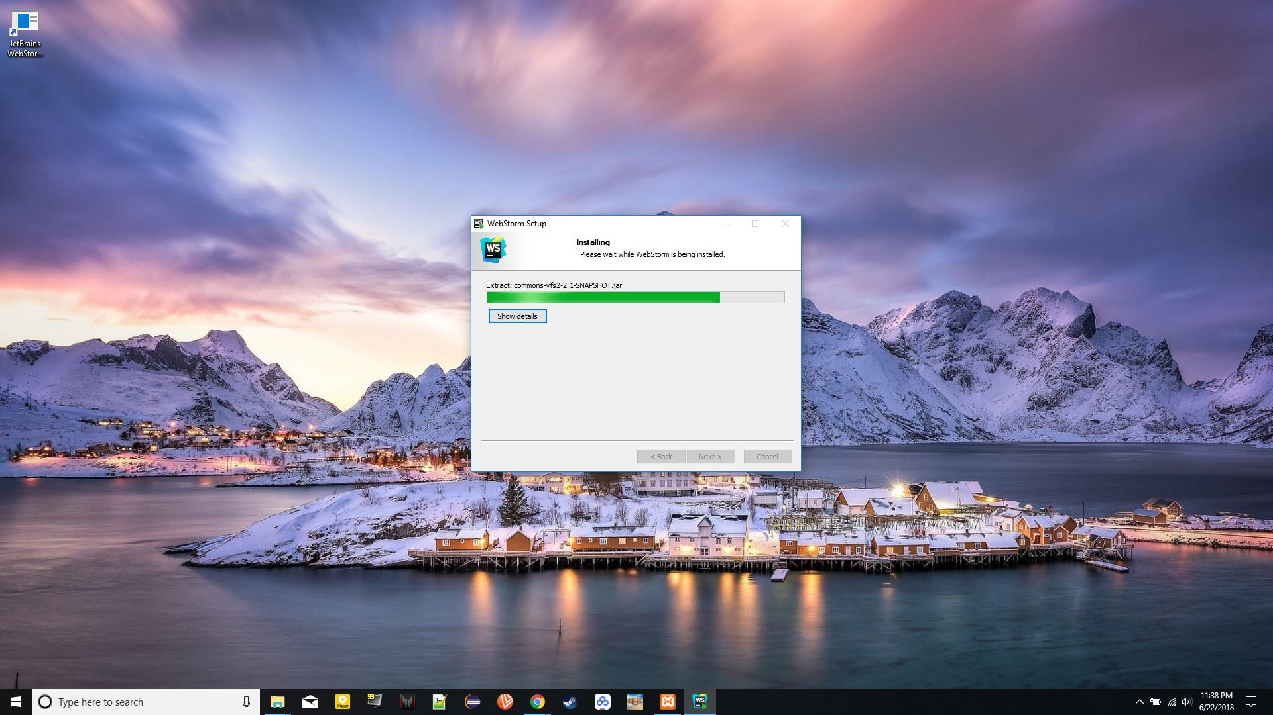

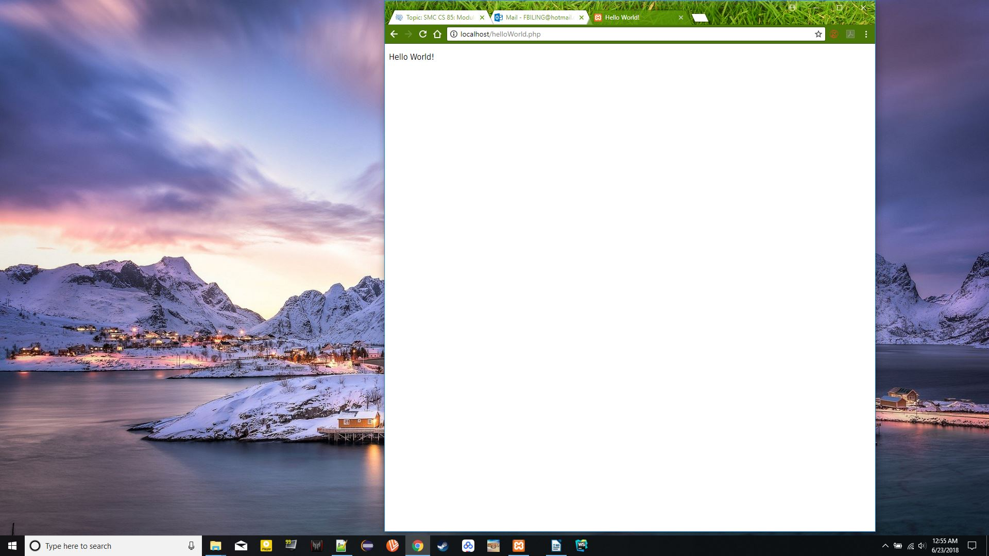screenshot of helloworld.php running on <http://localhost/helloworld.php>